**3) Retrieve the Student Information**

a) Write a query to retrieve student details, such as student name, contact information, and Enrollment status

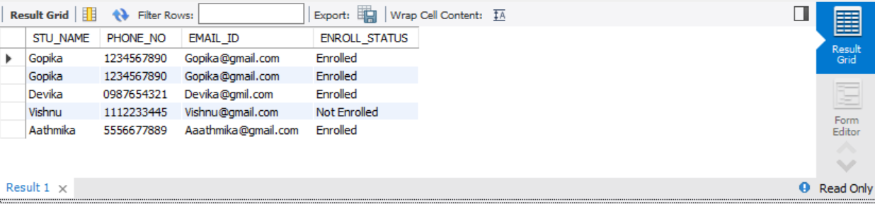

b) Write a query to retrieve a list of courses in which a specific student is enrolled.

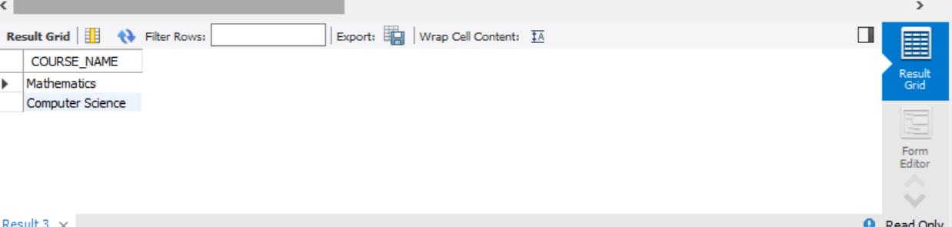

c) Write a query to retrieve course information, including course name, instructor information

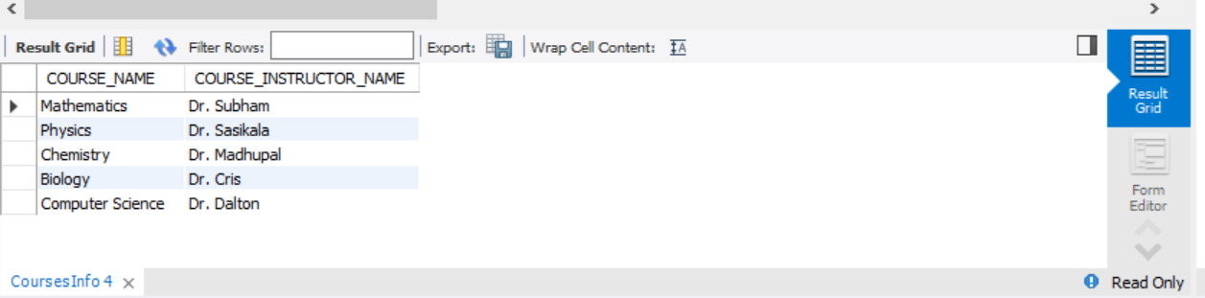

d) Write a query to retrieve course information for a specific course.

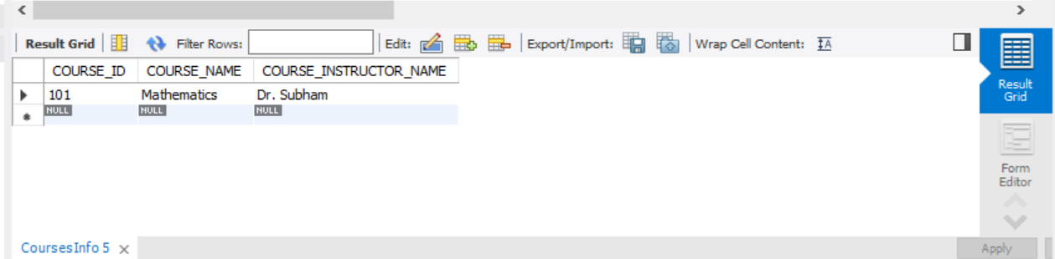

e) Write a query to retrieve course information for multiple courses.

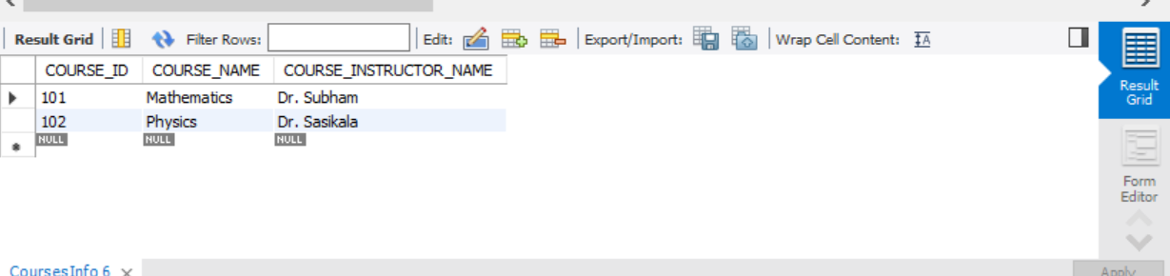

**4. Reporting and Analytics (Using joining queries)**

a) Write a query to retrieve the number of students enrolled in each course

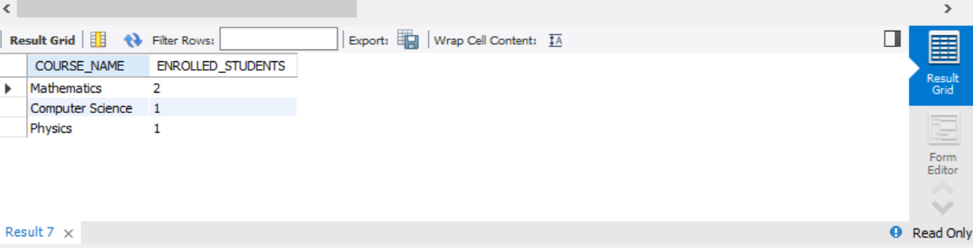

b) Write a query to retrieve the list of students enrolled in a specific course

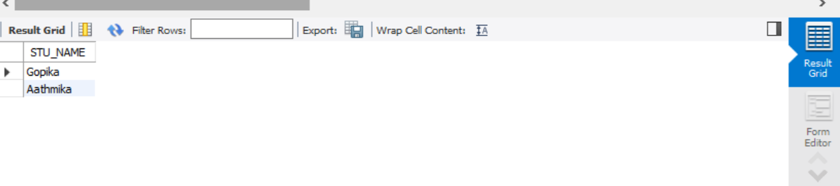

c) Write a query to retrieve the count of enrolled students for each instructor.

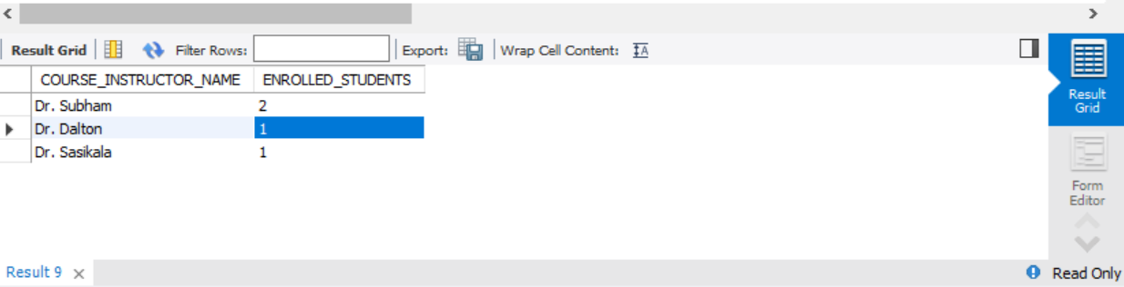

d) Write a query to retrieve the list of students who are enrolled in multiple courses

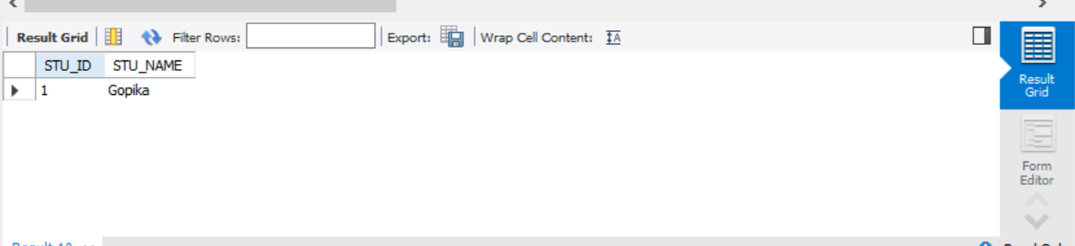

e) Write a query to retrieve the courses that have the highest number of enrolled students (arranging from highest to lowest)

